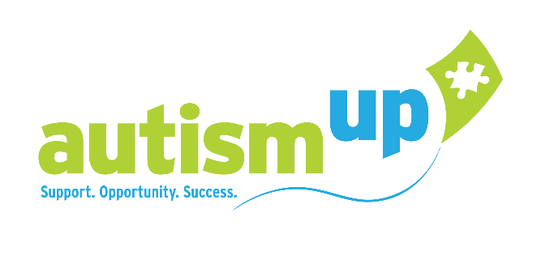
JOB ANNOUNCEMENT

Job Title: Full Life Academy Instructor

Location: AutismUp at the Golisano Autism Center, Rochester, New York

Hours: Part-time with the potential to become full-time, Monday-Friday, weekends and evenings as needed

Position Summary: The Full Life Academy Instructor will facilitate and provide program development, direct instruction, and oversight in a group setting that focuses on growth and skill development for participants. Instruction will be provided across all environments including the classroom and virtual, community, and job site. The Full Life Academy Instructor will develop and implement individualized curriculum.

Responsibilities: Facilitate and instruct participants with various abilities in a group setting. Responsible for the supervision and safety of program participants. Develop and implement curriculum and daily activities. Manage and direct support staff to be effectively assisting and supervising participants. Monitor and document participant progress. Work collaboratively with Director of AutismUp’s Center for Community Transition. Participate in team meetings, participant and family conferences. Partner with families and participants to provide input in ongoing planning and implementation.
Qualifications:
- Bachelor’s Degree in Education, Communication Science and Disorders, Human Services or related field
- A certification in secondary special education, Work Based Learning or Career and Technical Education preferred
- Minimum two years of work experience working directly with young adults of all abilities
- Coaching and/or educating parents of children with autism (or related disabilities)
- Demonstrated experience in a leadership role
- Demonstrated experience managing and supporting groups and individuals
- Strong language and communication skills (written and oral)
- Valid Driver’s License

About the Organization: AutismUp is the leading 501(c)3 autism support organization in the Greater Rochester and surrounding areas. Founded in 2004, by a small group of parents of children with Autism Spectrum Disorder, AutismUp has grown to include more than 2,300 family and professional member households.

Our Mission: To support individuals with Autism Spectrum Disorder, and their families, by expanding and enhancing opportunities to improve quality of life. Parent perspective steers the direction of the organization, with the fiduciary guidance of our Board of Directors. Together, we are providing help for today, and hope for tomorrow.
How to Apply: Email inquiries and resumes to: HR@autismup.org

Equal Employment Opportunity Policy
AutismUp provides equal employment opportunities to all employees and applicants for employment and prohibits discrimination and harassment of any type without regard to race, color, religion, age, sex, national origin, disability status, genetics, protected veteran status, sexual orientation, gender identity or expression, or any other characteristic protected by federal, state or local laws.

